Knative Basic Documentation (Linux)

Knative is split up into two independent components: **serving and eventing**. Each component can be installed separately, and not all of them need to be used depending on the scope of your project. In terms of function as a service, Knative is unique in that it **does not provide a level of abstraction for functions** compared to any other service. In other words, it does not have a separate category for defining functions, as OpenFaaS and other frameworks do. Rather, **it provides the same set of services like scalability and event triggering** that can be setup **for any Kubernetes-powered offering**. This is documentation is for a basic setup of Knative, but there are many other setup configurations that allow for more capabilities and features. For other options, check out <https://knative.dev/docs/install/any-kubernetes-cluster/>.

Prerequisites

* Kubernetes cluster installed and *kubectl* CLI
* Docker installed with a DockerHub account

Serving Installation

The Serving component of Knative “provides an abstraction for stateless request-based scale-to-zero services.” In other words, this provides the tool that allows users to implement the auto-scaling feature that is core to any function-as-a-service offering.

1. Install the Custom Resource Definitions (CRDs), which allow Knative to configure itself as a Kubernetes-native tool.

kubectl apply --filename https://github.com/knative/serving/releases/download/v0.15.0/serving-crds.yaml

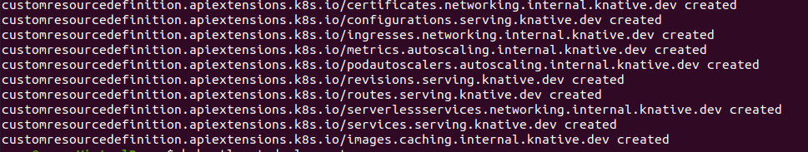Once completed, the terminal should show confirmation of the CRD extensions created.

1. Install the Knative Serving component, which is simply just a .yaml file that is deployed on top of your Kubernetes cluster to help manage it.

kubectl apply --filename https://github.com/knative/serving/releases/download/v0.15.0/serving-core.yaml

As with the previous step, you should see visual confirmation in the terminal, listing the different deployments, services, namespaces, etc. that were created from this process.

1. Knative relies on a **“networking layer” to abstract away the processes of traffic routing**, monitoring services, ingress, etc. The recommended provider is Istio which we will install in this step, but Knative offers support for many others such as Ambassador, Gloo, Kong, Countour, and Kourier.
   1. Download and extract the Istio release.

$ curl -L https://istio.io/downloadIstio | sh -

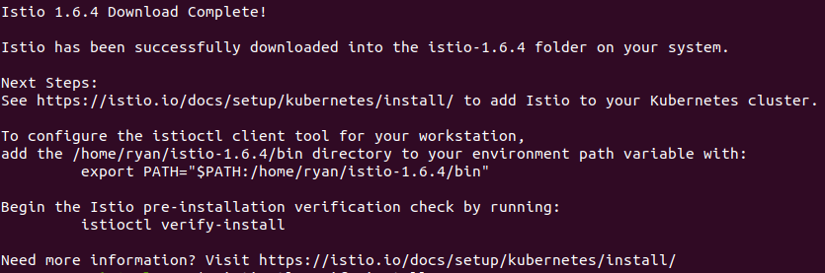A confirmation screen will appear in the terminal, verifying that the download was successful:

* 1. Move to the downloaded package directory and add the client to your path.

cd istio-1.6.4 && export PATH=$PWD/bin:$PATH

* 1. Install the default Istio configuration profile.

istioctl install

Once installed, a checklist of the different services and tools are displayed:



* 1. Finally, install Istio on Knative to allow them to function together.